Postgres tips

For mac os

1. Open Terminal
2. copying and pasting the following command into our command line:

(You should copy the two lines as just one command)

/usr/bin/ruby -e "$ (curl -fsSL https://raw.githubusercontent.com/Homebrew/install/master/install)"

1. then you will get (might not exactly same but similar)

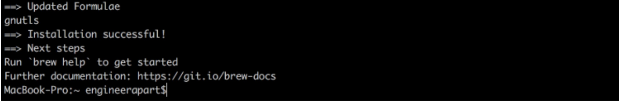

1. run the following commands:

brew install postgresql

1. then you will get (might not exactly same but similar)

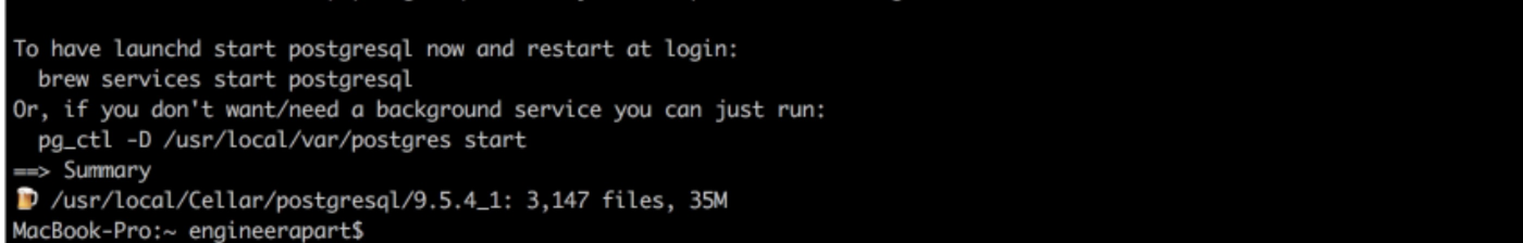

1. copy and paste following command and run:

pg_ctl -D /usr/local/var/postgres start && brew services start postgresql

1. Test if the postgres work:

postgres -V

pay attention: the V should be capital V !!!

1. You should see your version info like:

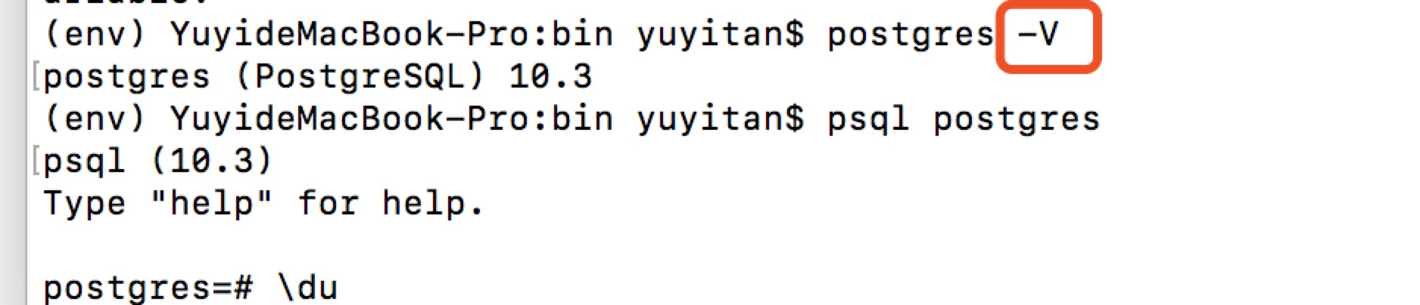

Congrat! You got postgres Now!

You can have a small test… but… I’m gonna sleep now! since I’m tooooooo sleepy!

Good night…!

Reference : <https://www.codementor.io/engineerpart/getting-started-with-postgresql-on-mac-osx-are8jcopb>